

**Neutral Citation Number: [2024] UKUT 189 (LC)**

**Case No: LC-2023-694**

# IN THE UPPER TRIBUNAL (LANDS CHAMBER) AN APPLICATION UNDER SECTION 84 OF THE LAW OF PROPERTY ACT 1925

**17 July 2024**

**TRIBUNALS, COURTS AND ENFORCEMENT ACT 2007**

***RESTRICTIVE COVENANT – MODIFICATION – planning consent for new dwelling in garden – restriction of buildings to existing private dwelling house and premises – whether restriction ought to be deemed obsolete – application refused***

**BETWEEN:**

**MICHAEL LACKEY**

**Applicant -and-**

**JOHN AND SUSAN PEARCE**

# Objectors

**14 Penina Avenue, Newquay,**

**Cornwall,**

**TR7 2LE**

**Diane Martin MRICS FAAV**

**25 April 2024**

**Truro Combined Court Centre**

The applicant representing himself

Mr John Pearce representing the objectors

**© CROWN COPYRIGHT 2024**

The following case is referred to in this decision:

*Re Fermyn Wood* [2018] UKUT 0411 (LC)

# Introduction

1. Penina Avenue rises up away from the A392, as it passes along the Gannel Estuary on the southern edge of Newquay. It is part of a residential development built in the mid-1970s and known originally as the Mellanvrane Lane Estate. The houses are either single storey bungalows or chalet bungalows (with accommodation in the roof space) and a particular feature of the houses on Penina Avenue and the adjoining roads to the west is that they have generously sized rear gardens.
2. Mr and Mrs Lackey have owned 14 Penina Avenue since April 2015. The objectors, Mr and Mrs Pearce, live in the neighbouring property, 16 Penina Avenue, which they purchased in December 1980. The rear garden of No 14 has a boundary with Wych Hazel Way and on 9 March 2023 Cornwall Council granted outline planning permission for a new two bedroom detached dwelling to be constructed there, with access onto Wych Hazel Way.
3. Mr Lackey says that he and his wife intend to down-size to the new smaller property and sell No 14 to pay for the new house and fund their retirement. Following receipt of advice on a previous application in 2022, the proposed dwelling was redesigned to a smaller footprint and reduced from three bedrooms to two. The bedrooms will be on the ground floor, which is to be set into the bank of No 16’s higher level garden, so that only the first floor will be visible to the neighbouring properties.
4. The plan below shows the relationship of the two neighbouring properties and the site of the proposed new dwelling. The properties on Penina Avenue, along with others on neighbouring roads, are all subject to a restriction imposed when the land was sold for development in 1973 which impedes erection of the proposed new dwelling. At that time No 14 was known as Plot 29, Mellanvrane Lane Estate.

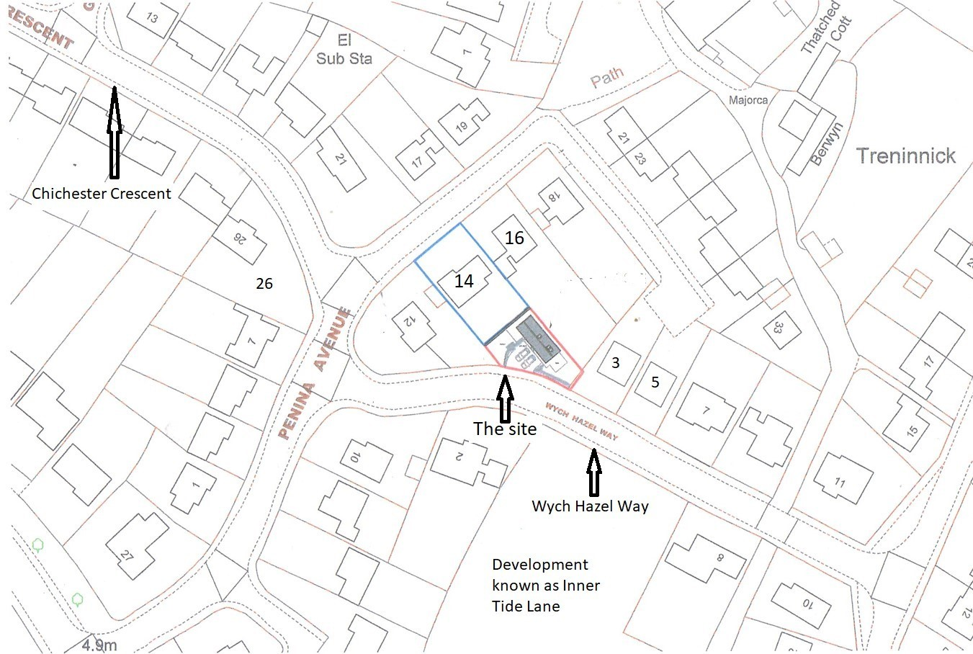

1. On 18 October 2023, on the advice of his solicitor, Mr Lackey made an application to the Tribunal under ground (a) of section 84(1) of the Law of Property Act 1925 for discharge of the restriction impeding his proposed development. This was subsequently amended to an application for modification under ground (a) to permit the proposed development. In accordance with the Registrar’s directions, Mr Lackey served notice of his application on a total of 58 local residents at 21 addresses in Penina Avenue, 11 addresses in Wych Hazel Way, 11 addresses in Chichester Crescent and 15 addresses in Inner Tide Lane (a recent development shown indicatively on the undeveloped area in the plan above).
2. Initially two objections were received, but one was withdrawn leaving Mr and Mrs Pearce as the sole objectors.
3. I made an inspection of the application site and the surrounding area on the afternoon of Wednesday 24 April 2024. A hearing of the application took place in Truro Combined Court Centre on the morning of Thursday 25 April 2024 under the simplified procedure. Neither party was represented, and no witnesses or experts were called to give evidence.

# The statutory background

1. Section 84(1) of the Law of Property Act 1925 gives the Tribunal power to discharge or modify any restriction on the use of freehold land on being satisfied of certain conditions. The applicant in this case relied only on ground (a) and unless this ground is made out the Tribunal has no jurisdiction to modify or discharge the covenant.
2. Ground (a) of section 84(1) is satisfied where it is shown that by reason of changes in the character of the property or neighbourhood or other circumstances of the case that the Tribunal may deem material, the restriction ought to be deemed obsolete.
3. In determining whether the restriction ought to be discharged or modified, the Tribunal will take into account the development plan and any declared or ascertainable pattern for the grant or refusal of planning permissions in the relevant area, as well as the period at which and context in which the restriction was created and any other material circumstances.
4. If the applicants are able establish that the Tribunal has jurisdiction to modify the covenant, the Tribunal then has to decide whether or not to do so. If the applicant agrees, the Tribunal may also impose an additional restriction on the land at the same time as modifying the original restriction.

# The restriction

1. A conveyance of Plot 29, Mellanvrane Lane Estate dated 2 March 1973 (“the 1973 conveyance”) between A.J.L. Limited (“the Vendor”), Barclays Bank Limited (“the Bank”) and Norman Frederick Welch and Hazel Yvonne Welch (“the Purchasers”) contained (as far as is relevant) the following recital 4) and clauses 3 and 4:

“WHEREAS:-

…

4) The whole of the land edged green on the plan attached hereto forms or formerly formed part of the Vendor’s Mellanvrane Lane Estate (hereinafter called ‘the Estate’) and has been laid out by the Vendor before the sale of any part thereof in building plots as shown on the said plan And it was intended that each plot should be sold subject to restrictive covenants which would enure for the benefit of all the plots comprised in the Estate and the Purchasers have accordingly agreed to enter into the covenants on their part hereinafter contained…

NOW THIS DEED WITNESSETH as follows:…

* 1. For the benefit of the owners or occupiers for the time being of the said landedged green on the said plan or any part thereof the Purchasers hereby jointly and severally covenant with the Vendor that they the Purchasers and the persons deriving title under them will at all times hereafter duly observe and perform all and singular the restrictions and stipulations mentioned in the First Schedule hereto…
  2. The Vendor reserves unto itself so long as it remains owner of any part of the Estate the right to release or vary any of the said restrictions or stipulations or to sell any part of the Estate for the time being unsold subject to different restrictions provided that this right shall not be exercised so as to destroy the general character of the Estate as a high-class residential area.”

1. The First Schedule to the 1973 conveyance stated:

“1. No building shall be erected on the land hereby conveyed except the private dwellinghouse and premises now in the course of erection thereon.

…

1. The previous consent in writing of the Vendor shall be obtained to all plans specifications and elevations of any additional building or alteration to the existing buildings and no addition or alteration thereto shall be made at any time unless the proposed addition alteration or deviation shall have been first Approved in writing by the Vendor whose fee of three pounds fifty pence for such consent and approval shall be paid by the Purchasers or persons making the application.”

# The application and the objection

1. Mr Lackey says that there have been substantial changes in the character of the neighbourhood since the restriction was imposed in 1973 which make it obsolete. The restriction was imposed at a time when the development of the Mellanvrane Lane Estate was at an early stage and significant development has taken place in the 50 years since. In particular, land opposite the application site on Wych Hazel Way has been developed recently as Inner Tide Lane, land adjoining the application site on Wych Hazel Way has been infilled with two dwellings, Nos 3 and 5, and 11 Wych Hazel Way has been extended and converted from one into two dwellings. Also, 26 Chichester Crescent, which is on the corner with Penina Way opposite No 14, has almost doubled in size recently by a ground floor extension and provision of first floor accommodation.
2. In order to comply with paragraph 2 of the First Schedule, Mr Lackey has obtained approval of his plans from Jon-Claude Luxon, managing director of A J Luxon Ltd, the family company that was the Vendor in the 1973 conveyance and which continues to carry out development to the surrounding area. The current fee is £250 and approval was confirmed by a seal of AJL Ltd stamped on to the plans with planning permission. Mr Luxon told Mr Lackey that approvals had been granted for around 15 properties to enable modifications.
3. In his application, Mr Lackey provided copies of the title documents for No 14, which included the 1973 conveyance and a plan attached to it. A copy of the plan is provided below, showing (as the outer line) the “land edged green”. At the top the line cuts through the plot on which No 16 is built, suggesting that it is not complete, and the recital at 4) refers to the land edged green forming “part” of the “Vendor’s Mellanvrane Lane Estate” so it is not expressed to provide a complete definition of the Estate. However, the line on the right hand side appears to follow a natural feature, such as a track or ditch, along the eastern boundary of the lower plots, which suggests that it is the defined outer edge of the Mellanvrane Lane Estate on that side.

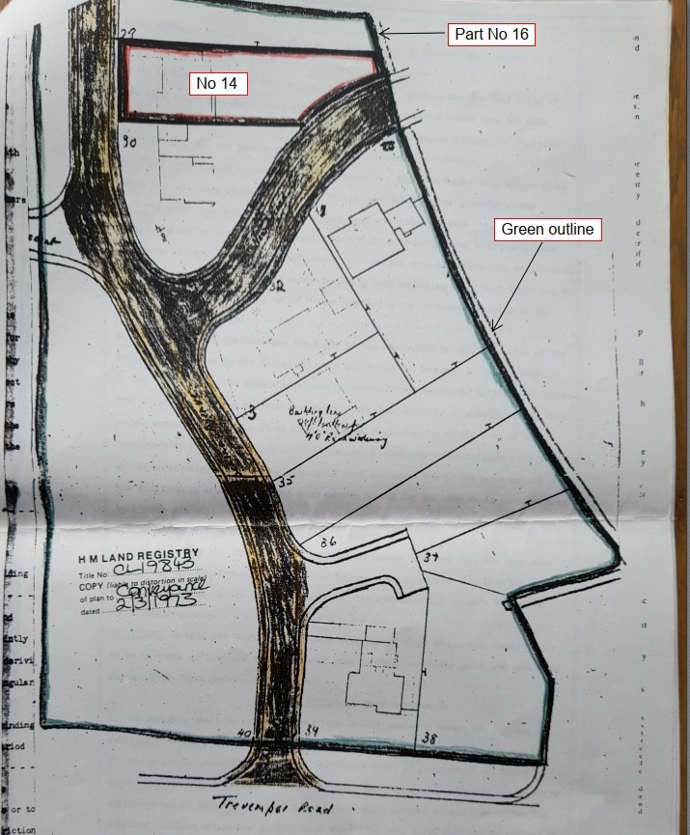

1. In the charges register of the title document reference is made to covenants on the part of

A J L Limited (the Vendor in the 1973 conveyance) in a conveyance of 14 Wych Hazel

Way dated 17 July 1975 (“the 1975 conveyance”) in which it is also the Vendor. The details are set out in the schedule of restrictive covenants to the title document for 14 Penina Avenue as follows:

“For the benefit and protection of the property hereby conveyed or any part or parts thereof and so as to bind so far as may be the remaining plots on the Trenninick Estate into whosesoever hands the same may come the Vendor hereby covenants with the Purchaser that the Vendor and the persons deriving title under it will as respects each and every of such remaining plots hereafter observe and perform the said restrictions and stipulations set out in the Second Schedule hereto but so that neither the Vendor nor the persons deriving title under it shall be liable for a breach of this covenant occurring in respect of the remaining portion of the Treninnick Estate or any part or parts thereof after it or they shall have parted with all interest therein Provided nevertheless and there is hereby reserved unto the Vendor so long as it shall remain the owner of any part of the Trenninick Estate the right to release or vary any of the said restrictions or stipulations or to sell any such part of the Trenninick Estate for the time being unsold subject to different restrictions and stipulations but not so as to alter the general character of the Trenninick Estate.”

1. The restrictions and stipulations in the Second Schedule (referred to in the extract above) are the same as those in the First Schedule to the 1973 conveyance. Confusion has arisen in two respects from the reference to the 1975 conveyance in the title document. Firstly, it concerns a property known as 14 Wych Hazel Way, which does not have an obvious connection with 14 Penina Avenue. Secondly it refers to the Trenninick Estate rather than the Mellanvrane Lane Estate as named in the 1973 conveyance.
2. Mr and Mrs Pearce say that development of the Mellanvrane Lane Estate took place on one part of land originally known as Treninnick Farm and that Mr Lackey is confusing the Mellanvrane Lane Estate to which the 1973 conveyance referred with the much wider area known generally as the Trenninick Estate. Within that wider area, outside the borders of the Mellanvrane Lane Estate, significant new developments have taken place over the last 20 to 30 years at higher densities. Mr and Mrs Pearce say that when they first moved to No 16 in 1980 the Mellanvrane Lane Estate comprised approximately 50 dwellings located on Penina Avenue, Chichester Crescent, Gresham Close, Mellanvrane Lane and part of Trevemper Road. They have indicated that area with hatching on the plan below, with the lower eastern boundary following the same line as that in the plan attached to the 1973 conveyance.

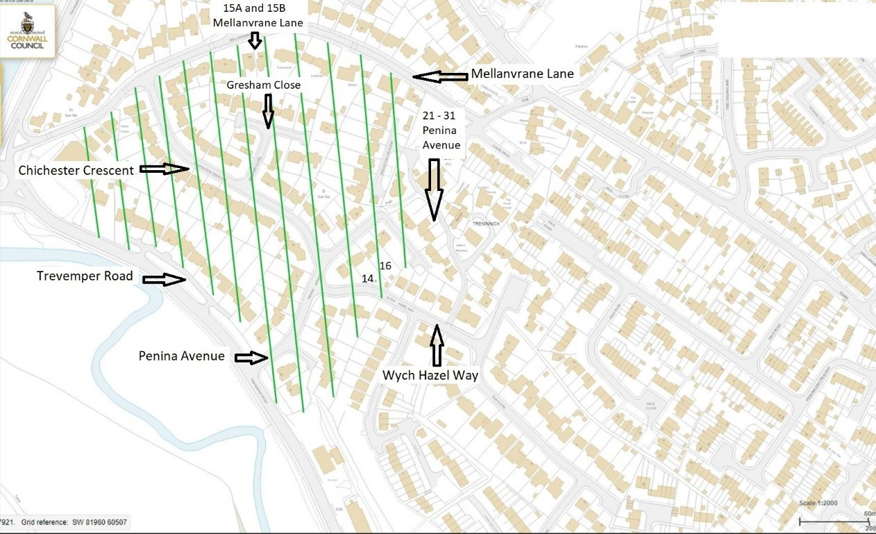

1. Mr Lackey does not dispute that the hatching identifies the Mellanvrane Lane Estate at that date, but he says that the proposed dwelling fronts on to Wych Hazel Way, has been designed to be in-keeping with the aesthetic of Wych Hazel Way, and should be considered in the context of the wider Trenninick Estate.
2. Mr and Mrs Pearce say that the words in clause 4 of the 1973 conveyance (which for their property were contained in a conveyance dated 18 December 1970) make it clear that the restriction was imposed to protect the Mellanvrane Lane Estate as laid out in the original plan as a “high class residential area”. This is not mentioned in the covenants in the 1975 conveyance, which refers instead to “the general character of the Trenninick Estate”. They point out that the density of development to the east of the hatched area, which includes Wych Hazel Way, is higher and the size of plots smaller. They say that within the hatched area the only changes made to properties have been alterations and extensions of the original single dwelling house, with no additional built form to undermine the prevailing character of the Estate. The restriction has protected the very different character of the Mellanvrane Lane Estate and is therefore not obsolete.
3. Mr and Mrs Pearce say that they chose their property in 1980 because of the layout and space afforded to each plot, providing green space and privacy for the residents. Should modification be made to allow Mr Lackey to build in his garden then this would set a precedent for other properties also subject to the covenant to seek to build in their gardens. Mr Lackey says that since very few properties have boundaries to two roads that is not a real issue, but Mr and Mrs Pearce say that there have been planning applications made to develop back land, for example by demolition of garages to provide access, although none has been successful.

# The issues

1. In the case of *Re Fermyn Wood* [2018] UKUT 0411 (LC) the Tribunal (Deputy President Martin Rodger QC and Mr Andrew Trott FRICS) identified four connected matters to be considered for an application under ground (a):

“35. In determining whether the 1929 covenant can be discharged under ground (a) it is therefore necessary to consider a number of connected matters. It is first necessary to identify the purpose or object of the covenant, which may be stated in the instrument imposing the restriction or may be inferred from the nature of the restriction or from the known circumstances. Next it is necessary to ask whether the character of the property or the neighbourhood has changed since the covenant was imposed. Thirdly, whether the restriction has become obsolete by reason of those changes, in the sense that the object for which the restriction was imposed can no longer be achieved. Fourthly, and finally, whether some material circumstance other than a change in the character of the property or the neighbourhood has had that effect.”

1. Although this application is for modification, not discharge, the same principles apply and I will now look at each of those four matters in the context of this application.
   1. *What was the original purpose of the restriction?*
2. The reference in clause 4 of the 1973 conveyance to the “general character of the Estate as a high-class residential area” is in connection with the Vendor’s retention of “the right to release or vary any of the said restrictions or stipulations”. The mutual covenants of clause 3, “for the benefit of the owners or occupiers for the time being of the said land edged green on the said plan or any part thereof” do not have those words, but the words can certainly be understood to have relevance as the original purpose of the restriction.
3. It is not clear what exactly might be meant by the term “high-class residential area”, but I accept the point made by Mr and Mrs Pearce that plans and satellite views of the area show clearly the larger sized plots and lower density of development with the bounds of the Mellanvrane Lane Estate. I agree that an important part of the purpose of the restriction was to retain that lower density, and therefore the amenity of spaciousness.
   1. *Has the character of the property or the neighbourhood changed since 1973?*
4. It is helpful first to identify the extent of the benefited land within the wider neighbourhood. The 1973 conveyance identifies in recital 4) “the land edged green” as forming part of the “Vendor’s Mellanvrane Lane Estate”. At clause 3 the covenant to observe the restriction is stated to be “For the benefit of the owners and occupiers for the time being of the said land edged green…”. The boundary of the “land edged green” on the plan to the 1973 conveyance does not extend eastwards of the plots along Penina Avenue and therefore all of Wych Hazel Way to the east of the line is excluded from the benefit of the restriction. Although it is not completely within the line on the plan, it is not in doubt that the land on which No 16 stands does benefit from the restriction.
5. I was able to walk along the roads within the area defined as the Mellanvrane Lane Estate, and the roads to the east of it, notably Wych Hazel Way. I have also had the benefit of studying the plans provided by the parties. In the hearing I opened up a digital satellite map of the area, which I reviewed with the parties to allow them to identify and discuss any further development within and outside the Mellanvrane Lane Estate.
6. Within the Mellanvrane Lane Estate, in addition to the recent significant extension to a property at 26 Chichester Crescent, the parties agreed that there did appear to have been infilling at some point to a large plot at 15 Mellanvrane Lane with the two newer properties numbered 15A and 15B. These are chalet bungalows, built at a higher density than the neighbouring properties, which are larger and different in age and character from most of the estate.
7. However, the most noticeable changes to the character of the neighbourhood are in the immediate vicinity of Nos 14 and 16. Penina Avenue has a right-angle spur, at the top of the hill above No 18, where three pairs of two storey semi-detached houses, Nos 21 – 31 Penina Avenue have been built. These appear to date from the 1980s and are very different in character from the chalet bungalows. They look down over the back gardens of Nos 14, 16 and 18 Penina Avenue and are very evident from within the garden of No 16. They are less evident from the back garden of No 14, which sits at a lower level.
8. Also evident from the back garden of No 16 is the adjoining side elevation of No 3 Wych Hazel Way, one of the two houses built just outside the Mellanvrane Lane Estate boundary by infilling. Again, due to its lower level, the back garden of No 14 is not so dominated by the side elevation of No 16, but it does look straight across Wych Hazel Way at the recently built contemporary style two storey houses at Inner Tide Lane.
9. We do not have the benefit of a plan showing the full extent of the original Mellanvrane Lane Estate, in order to say conclusively whether the land on which Nos 21 – 31 Penina Avenue have been built was within the boundary of it. They seem not to have been part of the original development and they are of a very different character so it seems unlikely that they were.
10. What I can conclude from my inspection is that the character of the property, No 14, has not obviously changed since 1973 and nor has the character of the vast majority of the contemporaneous properties built within the area accepted by the parties to be the Mellanvrane Lane Estate. There have been some extensions and alterations, but the only instance of intensification by infilling with new dwellings appears to have been at 15 Mellanvrane Lane, where houses similar to Nos 14 and 16 were provided between houses of different character. By contrast the character of the wider neighbourhood above and behind the properties, in the wider Treninnick Estate, has changed considerably since 1973 by the continued extension of residential development at generally greater density.
    1. *Has the restriction become obsolete by reason of those changes, in the sense that the object for which the restriction was imposed can no longer be achieved*
11. Assuming, as I do, that the original purpose of the restriction was to retain lower density development, and therefore the amenity of spaciousness, within the Mellanvrane Estate, then that object has been achieved and continues to be achieved. Whilst the rear gardens of Nos 14 and 16 are now overlooked by more recent developments above and behind them, and the outlook from their gardens is towards newer houses at greater density, the fact that their gardens are generous and spacious gives them a valuable level of separation from those new developments. They do not have great privacy, but what amenity they do have is created and maintained by the size of their plots. The restriction ought not therefore to be deemed obsolete.
    1. *Has some material circumstance other than a change in the character of the property or the neighbourhood had the same effect?*
12. Mr Lackey was conscientious in seeking the approval of A J L Ltd to his plans and the fact that A J L Ltd gave their consent, as they say they have done for other modifications, is evidence that they continue to exercise some control over the restriction. It is not clear that A J L Ltd are exercising any particular discretion to achieve the object of the original restriction, but it is evidence that the restrictions in the First Schedule of the 1973 conveyance are still functioning rather than obsolete.
13. I was not made aware of any other material circumstances which would have the effect of rendering the restriction obsolete.

# Determination

37. I determine that I have no jurisdiction to modify the restriction on ground (a) that it ought to be deemed obsolete.

Diane Martin MRICS FAAV

Member, Upper Tribunal (Lands Chamber)

17 July 2024

# Right of appeal

Any party has a right of appeal to the Court of Appeal on any point of law arising from this decision. The right of appeal may be exercised only with permission. An application for permission to appeal to the Court of Appeal must be sent or delivered to the Tribunal so that it is received within 1 month after the date on which this decision is sent to the parties (unless an application for costs is made within 14 days of the decision being sent to the parties, in which case an application for permission to appeal must be made within 1 month of the date on which the Tribunal’s decision on costs is sent to the parties). An application for permission to appeal must identify the decision of the Tribunal to which it relates, identify the alleged error or errors of law in the decision, and state the result the party making the application is seeking. If the Tribunal refuses permission to appeal a further application may then be made to the Court of Appeal for permission.